"AN ANALYSIS ON PURCHASE OF RAW MATERIALS,
PRODUCTION, SALES OF KAMDHENU NXT TMT BARS AND
ITS FINANCIAL OPERATIONS - A CASE OF
HINDUPUR STEEL AND ALLOYS (P) LTD."

Submitted by
K. Mohammed Abdulla Khan (Reg. No. 2511421)

Industry Guide – Mr Pradip Kumbhakar – Genaral Manager
Faculty Guide- Dr. Chithra S – Asst.Professor

CONTENTS
Section
Certificate
Company Certificate
Declaration
Acknowledgement
List of Tables
List of Figures
List of Abbreviations
Chapter 1: Introduction
Chapter 2: Company Profile
Chapter 3: Industry Profile
Chapter 4: Organisation Overview
Chapter 5: Internship Work Overview
Process Followed
Results Achieved
Conclusions, Learnings & Suggestions
Future Possibilities
Bibliography
Appendices

LIST OF TABLES
Table No. | Title
1.1 | Internship Schedule - Department-wise Rotation
2.1 | Basic Company Information
2.2 | Product Profile - MS Billets
2.3 | Product Profile - Kamdhenu NXT TMT Bars
2.4 | Manpower and Turnover Details
3.1 | Indian Steel Industry Overview
3.2 | Major Competitors Comparison
4.1 | Finance Department - Roles and Responsibilities
4.2 | HR Department - Roles and Responsibilities
4.3 | Marketing Department - Roles and Responsibilities
5.1 | TMT Bar Size, Weight & Bundle Chart
5.2 | Daily Profit & Loss Statement (5-day analysis)
5.3 | Key Performance Indicators (KPIs)
5.4 | Daily Power Consumption - Furnace vs Rolling Mill
5.5 | Production Efficiency - Yield Analysis
5.6 | Brand-wise Sales Breakdown (NXT vs KAY2)

LIST OF FIGURES
Figure No. | Title
2.1 | Organisation Structure Chart
2.2 | Raw Material Purchase Mix
3.1 | Seismic Zone Map of India (IS 1893:2025)
4.1 | Finance Department Structure
4.2 | HR Department Structure
4.3 | Marketing Department Structure
5.1 | TMT Bar Microstructure - Three Zones (Ring Test)
5.2 | Process Flow - Raw Material to Finished TMT Bars
5.3 | Daily Net Profit / Loss Trend
5.4 | Daily Sales Quantity vs. Breakeven

LIST OF ABBREVIATIONS
Abbreviation | Expanded Form
BIS | Bureau of Indian Standards
CCM | Continuous Casting Machine
CRS | Corrosion Resistant Steel
CSA | Cross-Sectional Area
DRI | Direct Reduced Iron
GM | General Manager
HR | Human Resources
IF | Induction Furnace
IS | Indian Standard
ISME | International School of Management Excellence
KPI | Key Performance Indicator
MS | Mild Steel
MSE | Medium Scale Enterprise
MSK | Medvedev-Sponheuer-Karnik (scale)
NHAI | National Highways Authority of India
OpEx | Operational Expenditure
PGDM | Post Graduate Diploma in Management
PSHA | Probabilistic Seismic Hazard Assessment
RM | Raw Material
TMT | Thermo-Mechanically Treated
TS | Tensile Strength
YS | Yield Stress

CHAPTER 1: INTRODUCTION
1.1 Introduction to Internship / Summer Training
Internship acts as a link between theory learned in classrooms and practice in industries. The summer internship program at ISME, Bangalore aims at exposing the students to practical knowledge of how businesses work and thus helping the students understand the working of organizations and developing professional skills as well as application of management knowledge practically.
The internship was conducted at Hindupur Steel & Alloys (P) Ltd., a plant producing TMT bars as franchisees of Kamdhenu Steel, which is one of the top-notch brands in India for steel. The company is based at APIIC Industrial Park, Gollapuram, Hindupur, Andhra Pradesh. The training period was from April 1, 2026 to May 31, 2026 for a total period of eight weeks in which I got exposure to the entire process of TMT bars production starting from procurement of raw materials and element testing, smelting, casting billets, rolling, quenching, final testing of quality, billing and finance.
The various aspects of internship were experienced throughout the entire organization in the following manner:
- Quality Control & Production (Weeks 1-2)
- Billing & Accounts (Weeks 3-4)
- Finance & Cost Analysis (Weeks 5-6)
- Production & Operations Analysis (Weeks 7-8)
1.2 Importance of Internship / Summer Training
Importance of the summer internship program can be highlighted in multiple aspects:
1. Practical use of management theories: The internship program was an opportunity to apply the theoretical knowledge gained in the field of operations management, financial accounting, cost analysis, and quality management in industry settings.
2. Understanding of cross-functionality: Through working across production, quality, billing, accounts, and finance departments, one could gain an insight into the integration of different functions for organizational purposes.
3. Exposure to the Industry: Steel manufacturing is essential for infrastructure development in India. Knowing the functioning, costing, quality issues, and dynamics of this industry would be very useful for any management student.
4. Skill Development: The internship provided an opportunity to develop various skills such as data analysis, report writing, documentation, communication, and problem-solving.
5. Career Exposure: This experience gave me exposure to several departments to understand the field of my interest and strength.
1.3 Objectives of the Study
Following objectives have been defined for this summer internship training program:
1. To understand the entire production process of TMT bars at Hindupur Steel & Alloys (P) Ltd. from raw material procurement to finished goods dispatch.
2. To learn about quality control techniques such as tensile test, Ring Test (Etching Test), and Spectro Lab test according to the standard IS 1786:2008.
3. To learn about the billing and accounting procedures which includes creation of invoice and tallying using tally software.
4. To know about financial operations which include purchase of raw material and analysis of sales.
5. To learn about production efficiency by conducting yield analysis (RM to billet, Billet to TMT).
6. To conduct profitability and breakeven analysis.
1.4 Scope and Period of Training
Period of Training: The internship was conducted for a duration of 8 weeks from April 1, 2026 to May 31, 2026.
Scope of Study:

The scope of this internship covered the following activities:
Week | Department | Key Activities
Week 1-2 | Quality Control & Production | Tensile testing, Ring Test, TMT production process, raw material testing (Spectro Lab), dispatch loading supervision
Week 3-4 | Billing & Accounts | Invoice generation, ledger maintenance, Tally entries, sales & purchase ledgers
Week 5-6 | Finance & Cost Analysis | Purchase/sales data analysis, operational costs (electricity, labour), Excel-based reporting
Week 7-8 | Production & Operations Analysis | Excel dashboard creation, profit/loss analysis, breakeven analysis, production efficiency tracking
Table 1.1: Internship Schedule - Department-wise Rotation
- Scope of Geographical Location: The research work was carried out at the Hindupur Steel & Alloys (P) Ltd. plant in APIIC Industrial Park, Gollapuram, Hindupur, Andhra Pradesh.
- Scope of Functional Areas: The study involved the areas of production, quality control, billing, accounts, finance, and operations.
1.5 Meaning of the Concept
TMT Bars (Thermo-Mechanically Treated Bars)
TMT bars are high-strength reinforcement bars that are employed in reinforced cement concrete (RCC). These bars are produced using a special technique where hot-rolled steel bars are instantly quenched using jets of water followed by auto-tempering utilizing residual heat inside the core. This produces the following unique three zone microstructure:
• Tempered Martensite (Outer Ring): Strength
• Bainite Transformation Zone (Middle): Toughness and shock resistance
• Ferrite Pearlite Core (Inner): Ductility and flexibility

Quality Control (QC) in Steel Manufacturing
Quality control in steel manufacturing involves systematic testing of raw material, intermediate materials, and final products to meet BIS standard like IS 1786:2008. Testing procedures involved are:
• Spectro Lab test (chemical composition test)
• Tensile test (yield stress, tensile strength and elongation)
• Ring Test (microstructural test)
Financial Operations
The financial operations in a manufacturing firm involve the purchase of raw materials, recording of purchases and sales, cost accounting (between fixed and variable cost), measuring of power consumption, labor cost control, and profit measurement.
Breakeven Point
The breakeven point measures the quantity of sales that will generate revenue equal to total cost (fixed and variable), thus making the firm to neither make profit nor incur loss. The breakeven quantity for Hindupur Steels was computed as 237 tons per day.
1.6 Rationale behind the Choice of the Topic
The topic "Analysis of Purchase of Raw Materials, Production, Sales and Financial Operations" was selected because of the following reasons:
1.End-to-end exposure: The internship provided an opportunity to rotate through different departments and get an end-to-end exposure from purchasing of raw materials to selling of final product.
2.Sector relevance: The steel sector is one of the key sectors of the Indian economy and hence the knowledge about it is very relevant for a management student.
3.Availability of Data: There were detailed records available regarding production, quality, purchasing, sales and financials.
4.Learning Opportunity: This topic provided me an opportunity to apply my learning of operations management, financial accounting, cost management and quality management.
5.Adding value to organization: The analysis carried out by me (5 day profitability dashboard, breakeven analysis, efficiency ratios) added value to the management.
1.7 Concept Implementation in Current Research
The method for concept implementation used in the present study is as follows:
Phase I: Observation & Training (Weeks 1-4)
• Observation of Production Process
• Quality Control Lab training
• Billing & Accounting
Phase II: Data Collection (Weeks 5-6)
• Collection of purchase, sales, production, and operating data
• Understanding of cost structure (energy, labor, raw materials)
Phase III: Data Analysis & Reporting (Weeks 7-8)
• Excel Dashboards Generation
• Computation of KPIs, Yield & Break-Even Point
• Generation of Final Report

CHAPTER 2: COMPANY PROFILE
2.1 Introduction to Company
Hindupur Steel & Alloys (P) Ltd. is a Private Limited Company that deals in the production of MS Billets and Kamdhenu NXT TMT Bars. This company was registered in the year 2009 and works as a franchisee of Kamdhenu Ltd., which is one of the most renowned steel brands in India. The company’s manufacturing unit is based in APIIC Industrial Park, Gollapuram, Hindupur, Andhra Pradesh.
Company Details:
- Complete Address: Plot No. 29, APIIC Industrial Park, Gollapuram, Hindupur Mandal, Andhra Pradesh - 515211
- Telephone: +91 9505681005
- Email: hindupursteelhup@gmail.com
- Website: (Operating under Kamdhenu brand)
Vision:
"To be a trusted and leading manufacturer of high-quality steel products in India, contributing to the nation's infrastructure growth through innovation, quality, and sustainable manufacturing practices."
Mission:
• To produce and distribute best-in-class MS Billets and Kamdhenu NXT TMT Bars in terms of quality and longevity
• To develop a lasting relationship with customers based on trust and transparency
• To achieve optimum use of resources, energy savings, and environment protection during manufacturing
• To contribute to socio-economic development of the region of Hindupur through employment and other social activities

Objectives:
• Increase yearly production capacity of MS Billets and TMT Bars
• Maintain ISO compliant quality standards throughout the entire manufacturing process
• Cement their presence in the markets of Andhra Pradesh, Karnataka, and nearby regions
• Upgrade their technological infrastructure for efficiency purposes
• Conform to all statutory, environmental and labor laws
2.2 Area of Operation
Hindupur Steel & Alloys (P) Ltd. is a company that operates at the national level in India, specifically targeting the southern and central states of the country.
Registered Office: Bangalore, Karnataka
Factory Location: APIIC Industrial Park, Gollapuram, Hindupur, Andhra Pradesh
Geographic Areas of Operation:
• Andhra Pradesh (primary market)
• Karnataka (secondary market)
• Tamil Nadu (emerging market)
• Telangana (emerging market)
The location of the factory close to NH 44 makes transportation of the products to the customers easier.
2.3 Nature of the Organization and its Business
Type of Industry: Manufacturing (Basic Iron & Steel)
Legal Status: Private Limited Company (Non-Government)
NIC Code: 271 – Manufacture of Basic Iron & Steel
Business Type: Business-to-Business (B2B) Manufacturing
Specific Functional Areas: Production, Quality Control, Finance & Accounts, Human Resources, Marketing & Sales
The company is engaged exclusively in the manufacturing of two core steel products:
- MS Billets (Mild Steel Billets) - semi-finished products for re-rolling mills
- Kamdhenu NXT TMT Bars - finished reinforcement bars for construction
2.4 Product or Service Profile
Table 2.1: Basic Company Information
Parameter | Details
Company Name | Hindupur Steel & Alloys Pvt Ltd
Incorporation Year | 2009
Type | Private Limited Company (Non-Government)
Head Office | Bangalore, Karnataka
Plant Location | APIIC Industrial Park, Gollapuram, Hindupur, Andhra Pradesh
NIC Code | 271 – Manufacture of Basic Iron & Steel
Core Products | MS Billets & Kamdhenu NXT TMT Bars
Authorized Capital | ₹30-35 Crore
Paid-up Capital | ₹20-25 Crore
Table 2.2: Product Profile - MS Billets
Parameter | Details
Product Name | MS Billets (Mild Steel Billets)
Grade | IS 2830 / IS 2831 compliant
Cross Section | 100mm x 100mm to 130mm x 130mm
Length | 3 to 12 metres (customizable)
Application | Re-rolling mills – conversion into TMT bars, angles, channels, rods
Key Property | High cleanliness, low sulphur/phosphorus content, uniform microstructure
Market | Local and inter-state re-rollers; B2B sales
Table 2.3: Product Profile - Kamdhenu NXT TMT Bars
Parameter | Details
Brand | Kamdhenu NXT
Standard | IS 1786:2008 (BIS Certified)
Grades | Fe-415, Fe-500, Fe-500D
Sizes Available | 8mm, 10mm, 12mm, 16mm, 20mm, 25mm, 32mm
Surface | Ribbed / Deformed (for superior concrete bonding)
Key Features | High ductility, corrosion resistance, earthquake resistance, weldability
Applications | Residential buildings, bridges, dams, flyovers, industrial structures
Advantages of Product:
• Strength: Complies with and surpasses BIS norms regarding yield strength and tensile strength
• Ductility: Due to soft ferrite-pearlite structure of core, product can bend without breaking – perfect for areas prone to earthquakes
• Resistant to Corrosion: Presence of tempered martensite rim helps provide resistance to oxidation naturally
• Weldability: Low carbon equivalent makes welding easy and effective
• Believability of Brand: Brand Kamdhenu NXT is well-known among builders, contractors, and governmental organizations

2.5 Size of the Organization
Table 2.4: Manpower and Turnover Details
Parameter | Details
Employee Strength | ~250-300 employees (including permanent and contractual)
Annual Turnover | ₹750 – 1,000 Crore (approx.)
Authorized Capital | ₹20-25 Crore
Paid-up Capital | ₹30-35 Crore
Plant Area | APIIC Industrial Park, Hindupur (dedicated industrial zone)
Production Capacity | Approx. 1,00,000 MT per annum (MS Billets + TMT Bars combined)
Current Production | ~600-700 Metric Tons per Day
Number of Shifts | 3 shifts (24-hour operations)
Classification | Medium-Scale Enterprise (MSE) under MSME definition
2.6 Organization Structure of the Company
Functional Organizational Structure is maintained by Hindupur Steel & Alloys (P) Ltd. Under this organizational structure, the employees are organized based on their specialization, which includes Production, Quality Control, Finance, HR, and Marketing, among others.
Figure 2.1: Organisation Structure Chart
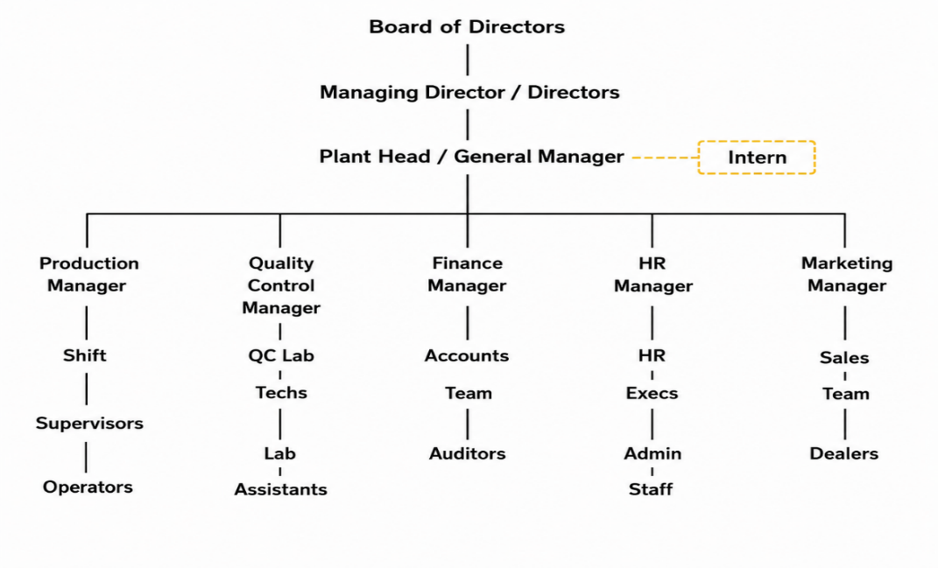

Important Functional Departments:
1. Production Department: Controls the induction furnace, billets casting, and TMT rolling mill production processes
2. Quality Control (QC) Department: Undertakes incoming raw materials inspection, inspection during process, and inspection of final product according to the specifications provided by BIS
3. Finance & Accounts: Includes budgeting, cost control, payroll management, statutory compliances, and banking relations
4. Human Resources (HR): Deals with recruiting, training, performance appraisals, welfare activities, and statutory compliances
5. Marketing & Sales: Includes customer sourcing, dealer relations, order processing, and dispatching

2.7 Information About Competitors
There exist some large integrated steel plants catering to the Indian steel industry other than many small secondary steel manufacturers. The primary rivals in the category of TMT bars and billets are:
Company | Key Products | Remarks
Tata Steel | TMT Bars, Structurals, Wire Rods | Integrated; Pan-India presence
JSW Steel | TMT Bars, HR Coils, Billets | Largest private steel producer
SAIL | TMT Bars, Billets, Plates | Government-owned; major long products
Jindal Steel & Power (JSPL) | TMT Bars, Billets, Rail | Strong in Central & Eastern India
Vizag Steel (RINL) | TMT Bars, Wire Rods | Located in AP; key regional competitor
Kamdhenu Ltd (other franchisees) | Kamdhenu TMT Bars | Direct brand-level competition
Figure 2.2: Raw Material Purchase Mix

The Hindupur Steel & Alloys Company is mainly engaged in competition in the regional arena within Andhra Pradesh and Karnataka. The strengths of the company include:
• Kamdhenu NXT brand value
• Location near the construction industry
• Scrap fed induction furnace cost effectiveness

CHAPTER 3: INDUSTRY PROFILE
3.1 Brief Profile of the Industry
Indian steel industry happens to be one of the most vital segments in the country’s economy. India now produces the second highest amount of steel in the world after China and even surpasses Japan in steel production.
Table 3.1: Indian Steel Industry Overview
Parameter | Value
India's Steel Production (2023-24) | ~144 Million Tonnes (MT)
Global Rank | 2nd Largest Steel Producer
Steel Consumption (2023-24) | ~136 MT
Per Capita Steel Consumption | ~97 kg (vs. global average ~228 kg)
Industry Contribution to GDP | Approx. 2% directly; 6-7% indirectly
Employment | Over 6 lakh direct; 20+ lakh indirect
Target (National Steel Policy 2017) | 300 million MT by 2030-31
India's steel industry has the following advantages:
• Substantial deposits of iron ore within the country
• A rising domestic market
• Extensive governmental support through spending on infrastructure
• Adequate supply of both skilled and semi-skilled labor
• Reasonable cost of manufacturing
The TMT bar category, which is part of the business of Hindupur Steel, occupies a major portion of the demand for long products due to construction work in residential, commercial, and infrastructure segments.

3.2 Current State of the Industry
Indian steel industry is currently experiencing rapid growth due to the government focus on the development of infrastructure through various schemes including:
• PM Gatishakti National Master Plan for multi-modal connectivity
• Smart Cities Mission
• Pradhan Mantri Awas Yojana (PMAY)
• Bharatmala Pariyojana
• Sagarmala
Important Industry Trends till 2024-26:
1. Demand for TMT Bars: There is high demand for TMT bars due to activities of construction and infrastructure industries. Housing industry alone accounts for around 60% consumption of TMT bars.
2. Raw Material Price Fluctuations: Scrap, iron ore and coking coal prices are constantly fluctuating owing to disruption in global supply chains and other geopolitical considerations.
3. Energy Cost: Power is one of the key inputs for manufacturing through induction furnace which makes Hindupur Steel vulnerable to rising power tariff in various states.
4. Environmental Norms: Pressure from National Green Tribunal (NGT) and State Pollution Control Board for emission norms and effluent treatment is on rise.
5. BIS Certification: Mandatory BIS marking for TMT bars (IS 1786) under the order of Steel & Steel Products (Quality Control) increases compliance requirements and eliminates several inferior products from the market.
6. Capacity Utilization: Secondary Steel industry (induction furnace route) has approximately 70-75% capacity utilization at national level.
7. Consolidation Trend: Consolidations are happening among larger firms to acquire smaller firms for realizing economies of scale.

3.3 Future Potential of the Industry
The outlook for the Indian steel industry and particularly the TMT bars industry looks very promising in the medium to long run:
1. National Steel Policy 2017 Targets: India is aiming at 300 million tonnage steel production capacity by 2030-31, which indicates large-scale capacity additions through the value chain. It means a doubling of the existing production capacity.
2. Infrastructure Pipeline: Capital expenditures by the government in building roads, railways, metro railway, port development, and affordable housing would ensure high TMT bars demand for the next decade. The National Infrastructure Pipeline (NIP) has announced over ₹111 lakh crores worth of projects.
3. Urbanization: India's urbanization level is forecasted to rise from ~36% (2023) to ~50% by 2050, which will lead to the requirement for residential constructions. One percent rise in the urbanization level increases steel demand by 10-12 MT.
4. Per Capita Consumption: India's per capita steel consumption of ~97 kg is much lower than the global per capita consumption of ~228 kg, which means there is much room left for increase in per capita consumption.
5. Export Opportunity: India is beginning to export steel to nearby nations and African countries; secondary manufacturers can gain an advantage by capitalizing on exports of billets and TMT bars.
6. Made in India: Government policies for local manufacturing such as production linked incentive scheme (PLI) for specialty steel will help quality-oriented manufacturers.
7. Shift Towards Green Steel: In future regulation, electric arc/induction furnace manufacturers (for example, Hindupur Steel) are likely to be favored over blast furnace manufacturers because they emit less CO2 per ton of steel. The world movement towards decarbonization is full of opportunities and threats at once.
8. Seismic Safety Awareness: Increased awareness about earthquake-proof construction following earthquakes in Delhi-NCR and other places has increased the demand for high-grade TMT bars (Fe 500D, Fe 550D).

CHAPTER 4: ORGANISATION OVERVIEW
4.1 Various Departments of the Organization
The main divisions of Hindupur Steel & Alloys (P) Ltd. are as follows:
1. Production Department
2. Quality Control (QC) Department
3. Finance & Accounts Department
4. Human Resources (HR) Department
5. Marketing & Sales Department
4.2 Functioning of Various Departments
4.2.1 Finance Department
Introduction: It is the duty of the finance department of Hindupur Steel & Alloys (P) Ltd to manage the finances of the organization, to maintain books of accounts and to take care of statutory compliance. They are closely related to the production, purchase, and sales departments of the organization to manage cost and profitability.
Finance Department Functions:
1. Financial Accounting & Book Keeping: Maintaining the account books for daily transactions, ledger accounts, and financial statements
2. Purchase & Sales Book Keeping: Recording the purchase of raw materials and the bills for supplies along with sales book keeping
3. Cost Control: Recording the manufacturing costs (raw material, power, labour) and calculation of cost per ton and areas of cost savings
4. Compliance: Filing of GST returns, deductions of TDS and its payments and other compliances related to finance
5. Payroll Management: Calculation and payments of salaries and making statutory payments such as PF, ESI
6. Banking & Treasury Management: Maintaining the bank accounts and transferring funds
7. Financial Statements Preparation: Preparing the profit and loss account and balance sheet along with MIS report
8. Budgeting & Variance: Preparation of annual budgets and variance from budgeting
Figure 4.1: Finance Department Structure
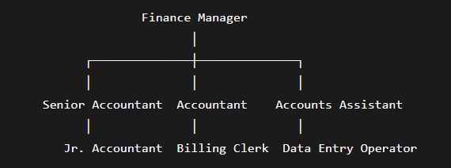

Table 4.1: Finance Department - Roles and Responsibilities
Level | Roles | Responsibilities
Finance Manager | Department Head | Overall financial management, statutory compliance, banking relationships, financial planning, cost analysis
Senior Accountant | Team Lead | Finalization of accounts, GST & TDS returns, payroll processing, MIS reporting
Accountant | Execution | Day-to-day accounting, ledger maintenance, invoice verification, Tally entries
Accounts Assistant / Billing Clerk | Support | Invoice generation, data entry, filing, document organization
4.2.2 Human Resources Department
Introduction: The Human Resource Department of Hindupur Steel & Alloys (P) Ltd. is responsible for managing the manpower strength of the company, which is around 250-300 people. The activities of the Human Resource Department include recruitment, training, employee welfare, compliance with labour laws, and creation of a positive work environment.
HR Department Responsibilities:
1. Recruitment and Selection: Determining manpower needs, recruitment, interviewing, and onboarding of new hires
2. Training and Development: Providing technical training to operators, safety training, and development of soft skills
3. Attendance and Leave Management: Monitoring attendance on a daily basis, maintaining leave data, and processing payroll
4. Statutory Compliances: Complying with Factories Act, PF, ESI, Bonus Act, Gratuity Act, and other labour Acts
5. Employee Welfare: Administering canteen facility, safety gadgets, health checkup, and grievances management
6. Performance Management: Annual performance appraisal and increment management
7. Contract Labour Management: Administration of contract labour and coordination with vendors of contract labour
Figure 4.2: HR Department Structure
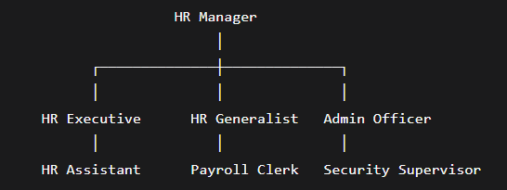

Table 4.2: HR Department - Roles and Responsibilities
Level | Roles | Responsibilities
HR Manager | Department Head | HR strategy, policy formulation, statutory compliance, employee relations, performance management
HR Executive | Recruitment & Compliance | Recruitment, onboarding, training coordination, PF/ESI compliance
HR Generalist | Operations | Attendance management, employee records, grievance handling, welfare activities
Admin Officer | Administration | Facility management, security supervision, canteen management, vendor coordination
4.2.3 Marketing Department
Introduction: The Marketing & Sales Department of Hindupur Steel & Alloys (P) Ltd. works for marketing and selling of Kamdhenu NXT TMT bars to various dealers, contractors and institutional customers. The department also performs the functions of customer relationship management, order processing and dispatch coordination.
Functions of Marketing Department:
1. Dealer Management: Dealer onboarding and management in Andhra Pradesh, Karnataka and other regions
2. Order Processing: Order receipt from customers and confirmation of products available or not
3. Sales Monitoring: Sales monitoring everyday with respect to quantity and amount, and sales monitoring for different brands (NXT and KAY2)
4. Customer Relationship Management: Customer relationship management for contractors, builders and institutional customers
5. Market Intelligence: Market intelligence like competitor price, trends and customer preference
6. Dispatch Coordination: Coordination for dispatch with production team
7. Brand Promotion: Brand promotion of Kamdhenu NXT through dealer meets, site visits and other means
Figure 4.3: Marketing Department Structure
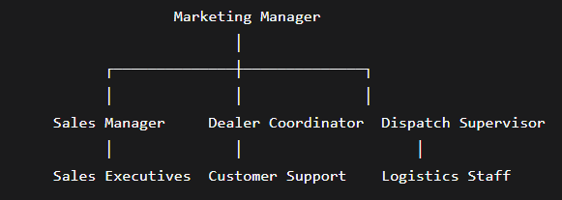
Table 4.3: Marketing Department - Roles and Responsibilities
Level | Roles | Responsibilities
Marketing Manager | Department Head | Sales strategy, dealer network development, pricing decisions, team management
Sales Manager | Sales Operations | Order processing, sales target achievement, customer relationship management
Dealer Coordinator | Dealer Management | Dealer onboarding, order coordination, payment follow-up
Dispatch Supervisor | Logistics | Loading supervision, vehicle coordination, delivery documentation

CHAPTER 5: INTERNSHIP WORK OVERVIEW
5.1 Tasks Performed
The internship involved rotation across four major functional areas over eight weeks. The tasks performed in each period are detailed below:
Weeks 1-2: Quality Control & Production Department
Tasks Performed:
- Tensile Testing (Grade Testing Laboratory):
- Rebar Samples Collection (8mm, 12mm, 20mm) every 30 minutes from Production Floor
- Sample Weight, Length, and Cross Sectional Area Measurement
- Tensile Testing Machine operation to calculate Yield Load, Tensile Load, Yield Stress, Tensile Strength, and Elongation Percentage
- Results recording and comparison with IS 1786:2008
2. Ring Test (Etching Test):
- Cross Section Samples Preparation of TMT Bars
- Samples Polishing up to Mirror Finish
- Nitric Acid (5-10%) in Ethanol Application (15-30 seconds)
- Microstructure Three-Zone Observation through Magnification
- Pass/Fail Criteria – Presence of Martensite Ring Continuity
3. Raw Materials Testing (Spectro Lab):
  - Preparing lollipop shaped samples from Raw Materials (Scrap, Sponge Iron, Pig Iron)
  - Sample Ground up to Flat Shining Surface
  - Spectro Lab Analysis (5-10 Seconds Per Test)
  - Elemental Composition Comparison with Standards Required

1. The TMT Production Process:
    - The induction furnaces were observed (melt temperature around 1380°C)
    - Billet casting was understood by the use of the CCM (continuous casting machine)
    - Rolling mill process was observed
    - The quenching & self-tempering process was studied
- Loading Supervision for TMT Bars Dispatch:
• Loading supervision for TMT bars of different diameters was carried out
• Order verification of customers with respect to quantity loaded
Weeks 3-4: Billing & Accounts Department
Task Accomplished:
1. Generating Invoices:
- Invoice creation procedure learned for TMT bars sales
- Correctness of customers' details, products specification, quantities and price ensured
2. Sales and Purchase Ledger Management:
- Managed sales and purchase ledger accounts
- Sorted daily transactions methodically
3. Tally Software Utilization:
- Recording transactions into Tally software
- Check entered data after recording
- Knowledge of basic accounting procedures on Tally
Weeks 5-6: Finance & Cost Analysis Department
Tasks Performed:
- Purchase Data Analysis:
- Collection and organization of raw materials' purchase data (turning & boring scrap, ingots & billets, sponge iron)
- Analysis of purchase quantity, value, and price per kg
- Material wise purchase report prepared
- Sales Data Analysis:
- Daily collection and analysis of TMT sales data (quantity and value)
- Brand wise analysis of TMT Sales (Kamdhenu NXT vs KAY2)
- Calculation of average selling price per ton
- Operating Cost Analysis:
- Daily recording of power consumption by furnace and rolling mill
- Cost of power calculated at ₹7 per unit
- Labor cost understanding
- Excel-based reporting:
- Purchase, sales and cost reports created in excel
- Tables and charts prepared
Weeks 7-8: Production & Operations Analysis
Tasks Performed:
1. Profitability Analysis
- Prepared a 5-day Profit and Loss Statement (from May 1st to 5th, 2026)
- Calculated Gross Profit and Net Profit
- Calculated Net Profit Margin (11.9% for 5 days)
2. Production Efficiency Analysis
- Calculated yield for raw material to billet conversion (83.9%)
- Calculated yield for billet to TMT conversion (95.8%)
- Identified wastage quantity and percentage
3. Breakeven Analysis
- Calculated daily fixed cost of operation (₹43.67 Lakhs)
- Calculated Contribution Margin per ton (₹18,414)
- Calculated Breakeven quantity (237 tons per day)
- Calculated Breakeven sales (₹1.26 Crore

5.2 Process Followed
Process 1: Manufacturing Process of TMT Bars
TMT bar manufacturing process at Hindupur Steel & Alloys (P) Ltd. is an entire process comprising of the following steps:
Step 1: Raw Material Collection
- Collection of scrap iron, sponge iron, pig iron, and gypsum
- Storing raw materials in scrap yard
Step 2: Raw Material Testing (Spectro Lab)
- Making of sample (lollipop shaped, polished flat)
- Analyzing sample using Spectro Lab (for 5-10 seconds)
- Decision-Making process – either to send to furnace or back to supplier
Step 3: Induction Furnace Melting Process
- Composition of charge used – around 6 tons of scrap and 14 tons of pellets/DRI (around 20 tons total)
- Melting process temperature – around 1380°C
- Power required for process -around 722 kWh per tonne
- Cycle time -around 3 hours per 18 ton batch
Step 4: Continuous Casting (CCM Unit)
- Molten steel poured into Continuous Casting Machine
- Solidifying into billets
- Output – around 18 tons of billets per heat (~11 billets of 840 kg each)
Step 5: Rolling Mill
- Billet reheating and passing through rolling stands
- Making billet of desired diameter (from 8 mm to 32 mm)
Stage 6: Quenching (Thermo-Mechanical Process)
    - Hot rod passes through water sprays
    - Martensitic structure formed on outer surface due to rapid cooling
    - The center of rod remains hot forming Ferrite-Pearlite structure
Stage 7: Self-Tempering Process (Air Cooling)
    - Heat from the center tempts the outer martensitic structure
    - Microstructure with three phases developed
Stage 8: Quality Inspection Tests
    - Conduct tensile test every 30 minutes
    - Conduct ring test (etching test) according to IS 1786
    - Conduct dimensional tests (check weight per meter)
Stage 9: Despatch
      - Packing based on size (8mm: 10 rods/piece, 20mm: 2 rods/piece, etc.)
      - Lading into vehicles
      - Delivery
Figure 5.1: Process Flow - Raw Material to Finished TMT Bars
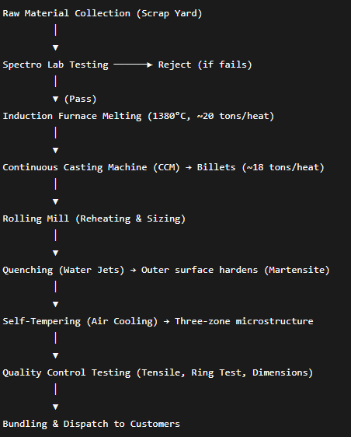
Process 2: Tensile Test Procedure (Repeated After Every 30 Minutes)
Step 1: Collection of sample from the production line at a fixed time
Step 2: Weight and length measurement of sample
Step 3: Calculation of cross-sectional area of sample
Step 4: Placing of sample in the tensile testing machine
Step 5: Gradual application of tensile load
Step 6: Measurement of yield load (elastic limit)
Step 7: Measurement of ultimate tensile load (point of breaking)
Step 8: Calculation of the following parameters:
• Yield Stress = Yield Load / CSA
• Tensile Strength = Tensile Load / CSA
• Elongation% = (Final Length – Original Length) / Original Length x 100
Step 9: Comparing results with IS 1786 standards
Step 10: Pass/Fail determination
Process 3: Ring Test (Etch Test) Process
Step 1: Cutting of cross-section from sample of TMT bar
Step 2: Cutting surface made highly polished
Step 3: Preparation of 5-10% Nital etching solution
Step 4: Highly polished surface soaked in Nital solution for 15-30 seconds
Step 5: Etched specimen is then taken out and cleaned
Step 6: Examination of microstructure under microscope
Step 7: Three regions are distinguished:
Tempered Martensite (Dark/black outer ring)
Transition region (Brown)
Ferrite & Pearlitic core (Light/white)
Step 8: If dark ring is continuous and intact, PASS
Step 9: If dark ring is interrupted, FAIL
5.3 Results Achieved
Result 1: 5-Day Profitability Analysis (May 1-5, 2026)
Based on the data collected and analyzed during Weeks 7-8, the following results were achieved:
Table 5.1: Daily Profit & Loss Statement
Date | Sales Revenue (₹) | RM Cost (₹) | Gross Profit (₹) | OpEx (Fixed) (₹) | Net Profit (₹) | Net Margin %
01-May-26 | 1,94,92,154 | 1,27,46,000 | 67,46,154 | 43,66,667 | 30,05,187 | 15.4%
02-May-26 | 1,48,30,556 | 96,98,000 | 51,32,556 | 43,66,667 | 13,91,589 | 9.4%
03-May-26 | 50,79,054 | 33,22,000 | 17,57,054 | 43,66,667 | (19,83,913) | -39.1%
04-May-26 | 2,06,16,455 | 1,34,86,000 | 71,30,455 | 43,66,667 | 33,89,488 | 16.4%
05-May-26 | 2,23,48,002 | 1,46,22,000 | 77,26,002 | 43,66,667 | 39,85,035 | 17.8%
Total | 8,23,66,221 | 5,38,74,000 | 2,84,92,221 | 2,18,33,335 | 98,02,558 | 11.9%

Table 5.2: Key Performance Indicators (KPIs)
KPI | Value
Total Sales Revenue | ₹8.24 Crore
Total Sales Quantity | 1,548.08 Tons
Total Net Profit | ₹98.03 Lakhs
Net Profit Margin | 11.9%
Average Selling Price | ₹53,205 per Ton
Average Variable Cost (RM) | ₹34,791 per Ton
Daily Breakeven Quantity | ~237 Tons
Daily Breakeven Revenue | ~₹1.26 Crore

Figure 5.2: Daily Net Profit / Loss Trend
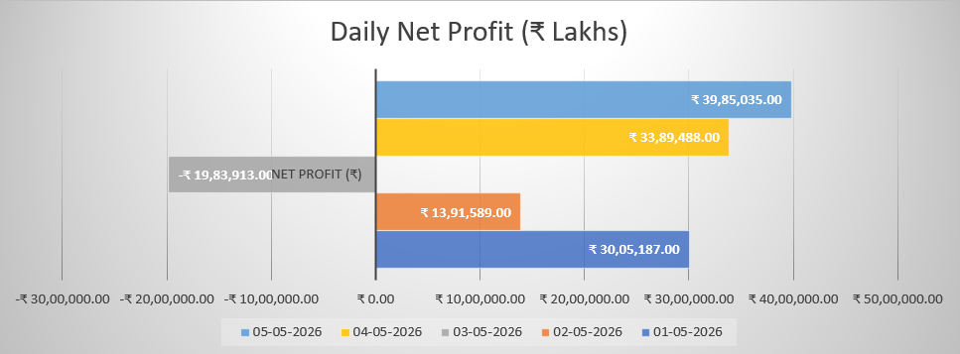
Important Finding: The firm is profitably operating on average days, however, on Day 3 (May 3), there was an important net loss of ₹19.83 Lakhs as the sales amount (95 tons) is less than the breakeven amount of 237 tons.
Result 2: Production Efficiency Analysis
Table 5.3: Production Efficiency - Yield Analysis
Process | Input | Output | Yield | Wastage
Raw Material → Billet | 1,775.20 Tons | 1,490 Tons | 83.9% | 285.20 Tons (16.1%)
Billet → TMT | 1,840.61 Tons | 1,744.55 Tons | 95.8% | 96.06 Tons (4.2%)
Key Finding: The rolling mill conversion process is very efficient with a yield rate of 95.8%. The initial smelting process can be improved as it has a yield rate of 83.9%.
Result 3: Power Consumption Analysis
Table 5.4: Daily Power Consumption - Furnace vs Rolling Mill
Parameter | Total Units | Total Cost (₹ @ ₹7/unit)
Furnace (5 days) | 11,94,600 | 1,19,84,000
Rolling Mill (5 days) | 2,35,900 | 16,65,800
Combined | 14,30,500 | 1,36,49,800
Key Finding: Electricity consumption in production is high, and the furnace consumes about 5 times more energy compared to the rolling mill.
Result 4: Brand-wise Sales Analysis
Table 5.5: Brand-wise Sales Breakdown (NXT vs KAY2)
Brand | Sales Quantity (Kgs) | Sales Value (₹) | Avg. Price (₹/Kg)
Kamdhenu NXT | 13,30,390 | 7,12,36,381 | 53.55
KAY2 | 2,17,690 | 1,11,29,840 | 51.13
Total | 15,48,080 | 8,23,66,221 | 53.20
Key Finding: Kamdhenu NXT (premium brand) accounts for 86% of sales quantity and achieves a ₹2.42/kg higher price realization compared to the KAY2 economy brand.

Figure 5.3: Daily Sales Quantity vs. Breakeven

Key Finding: Day 3 falls below the breakeven quantity of 237 tons and thus forms the only loss-making day.
5.4 Conclusions, Learnings & Suggestions
Conclusions
Conclusion based on the 8 weeks internship and 5 days analysis:
1. Financial Performance: Hindupur Steel & Alloys (P) Ltd. is inherently profitable with a net margin of 11.9% in the 5-day analysis period. The company made a sale revenue of ₹8.24 Crore and ₹98 Lakhs net profit.
2. Effect of Volume: High operating leverage is seen in the company. A mere low volume day (95 tons on May 3) makes up for the profit made in two profitable days. It is important to maintain sales above 240 tons each day.
3. Production Process: Rolling mill conversion (95.8% yield) is very good. Improvement scope is seen in the primary melting process (83.9% yield) of about 5-6%.
4. Quality Control: The company has strict quality control mechanisms through Spectro Lab (raw materials), tensile test every 30 minutes, and Ring Test (microstructure check). All these tests are done according to IS 1786:2008 norms.
- Brand Strategy: Premium brand Kamdhenu NXT accounts for most of the sales volume (86%) and generates more pricing power (₹2.42/kg above KAY2). Hence, franchising strategy is justified.
- Cost Structure: Electricity cost (₹1.37 Crore for 5 days) is the biggest cost factor, while furnace accounts for 83% of the total electricity cost.
Learnings
The internship provided the following key learnings:
Technical Learnings:
1. TMT Bar Manufacturing: Knowledge on all the stages of production right from raw materials to final production of TMT bars, which included induction furnace melting, continuous casting, rolling, quenching and self-tempering.
2. Quality Control: Learnt about tensile testing, ring test (etching test) for verifying micro structure and spectro lab for analyzing elements.
3. IS Standards: Acquired practical knowledge about IS 1786:2008 (for TMT bar standards), IS 1893:2025 (for seismic zones) and tolerances for various sizes of bars.
4. Industry Economics: Knowledge on cost structure, including electricity usage (₹7/unit, 722 kWh/tonne), raw material prices, labour charges and breakeven calculations.
Software & Analytical Learnings:
1. Tally Software: Familiarity with invoice preparation, journal updating, and record keeping
2. Excel Charts Building: Skill in preparing P&L statement, break-even analysis, productivity charts, and graphical representations
3. Data Analysis: Practical knowledge of data collection, arrangement, and analysis
Soft Skills Developed:
1. Communication: Engaging with department heads, supervisors, and workers from various departments
2. Documentation: Keeping records of daily report, bi-weekly report, and analysis
3. Problem-solving: Figuring out the reason for Day 3 loss (less sales volume) and determining breakeven point
4. Professionalism: Knowing about work environment, organizational hierarchy, and professionalism
Suggestions
After observations and analysis, the below suggestions are made to the management.
Suggestions for Management
Suggestion 1: Ensure Daily Sales Volume Stability
• Observation: Day 3 loss was due to sales volume of 95 tons, whereas breakeven volume was 237 tons
• Suggestion: Set a daily sales volume target of more than 240 tons
• Benefit: Avoidance of loss making days
Suggestion 2: Labour Cost Structure Optimization
• Observation: The labour cost of ₹43.67 Lakhs in 5 days (₹8.73 Lakhs per day) is taken as a fixed cost
• Suggestion: Make labour cost partially variable (performance-based incentive or optimal shift scheduling according to production volume)
• Benefit: Reduced daily breakeven point
Suggestion 3: Align Production with Sales Orders
• Observation: Billets manufactured (2,031 tons) were higher than the number of TMTs sold (1,548 tons) → increase in inventory
• Suggestion: Introduce production planning depending on real orders instead of producing at full capacity throughout
• Effect Expected: Lower inventory carrying costSuggestion 4: Investigate Root Cause of May 3 Sales Drop
• Observation: Sales fell from 277 tons (Day 2) to 95 tons (Day 3) with no apparent reason
• Recommendation: Find out whether this happened because of demand problem (no orders), supply problem (production problem), or distribution problem (no vehicles)
• Expected Result: Preventing recurrence
Suggestion 5: Improve Primary Melting Yield
• Observation: Yield from raw materials to billets is only 83.9%; there is scope for improvement
• Recommendation: Slag analysis to identify the metal loss; training of operators on ideal charging ratio
• Expected Benefit: Yield increase by an additional 5-6% will result in ₹50-60 Lakhs extra per annum
Suggestion 6: Consider Solar Power Investment
• Observation: Cost of power is ₹1.37 Crore in 5 days (projected at ₹8.2 Crore/month)
• Recommendation: Consider rooftop solar plant for reducing dependence on grid power
• Expected Advantage: Long-term reduction in variable costs and carbon emissions
FUTURE POSSIBILITIES
Based on the internship study and analysis performed, the following opportunities in the future are identified for Hindupur Steel & Alloys (P) Ltd.:
1. Increase in Production Capacity
Given the forecasted increase in demand of India’s steel market up to 300 MT till 2030-31, there is possibility for the company to look at increasing the production capacity from current 1,00,000 MT to 1,50,000-2,00,000 MT in the next 3-5 years.
2. Diversifying into Higher Grade Products
• Fe 550D and Fe 600 Grades: Increasing demand for high ductility TMT bars in seismic zones (North India) and infrastructure projects
• Corrosion Resistant Steel (CRS): Increasing demand in coastal regions (Tamil Nadu, Kerala, Andhra Pradesh)
3. Forward Integration into Construction
The firm may look at establishing a small construction division or tie-ups with developers for “Kamdhenu certified builders” concept.
4. Energy Efficiency Measures
•Solar Power Plant Installation (minimizing grid power dependence)
•Capturing waste energy from induction furnace (pre-heating scrap material or steam generation)
•Energy Efficient Motors & Variable Frequency Drives (VFD)
5. Digitization Strategy
• ERP Implementation: Integration of manufacturing, quality control, inventory management, sales and finance in one ERP software
•Dashboard System: Management dashboard that shows daily production, sales and comparison between profits and break-even
• Tensile Test Reporting: Automated digital report for tensile test result and automatic fail/pass notification system
- Export Potential
The company can capitalize on the increasing exports of steel from India to export billets to neighboring countries like Nepal, Bhutan, Bangladesh, Sri Lanka and Africa.
7. Dealership Expansion
Enhance business in Tamil Nadu and Telangana by on boarding dealers and visiting builders in the market.

BIBLIOGRAPHY
Indian Standards (BIS Codes):
- IS 1786:2008 - High strength deformed steel bars and wires for concrete reinforcement
- IS 1893:2025 - Criteria for earthquake resistant design of structures (Part 1: General provisions and buildings)
- IS 13920 - Ductile detailing of reinforced concrete structures subjected to seismic forces
- IS 2830 / IS 2831 - Carbon steel billets, blooms, and slabs for re-rolling
Text Books & References:
- Chandra, B. (2022). Steel Making. Tata McGraw-Hill Education.
- Ghosh, A. & Chatterjee, A. (2021). Iron Making and Steelmaking: Theory and Practice. PHI Learning.
- Bureau of Indian Standards (BIS). (2008). *Handbook on TMT Bars - IS 1786*. New Delhi: BIS Publication.
Websites & Online Resources:
- Bureau of Indian Standards (BIS) - www.bis.gov.in
- Ministry of Steel, Government of India - www.steel.gov.in
- Joint Plant Committee (JPC) - www.jpcindiansteel.com
- World Steel Association - www.worldsteel.org
- Kamdhenu Group - www.kamdhenugroup.com
Internal Company Documents (provided during internship):
- Size_and_bundle_chart.xlsx - TMT bar dimensional and bundle weight data
- 5-day purchase, production & sales data (May 1-5, 2026)
- Spectro Lab test reports (various dates)
- Tensile test records (Grade Testing Laboratory)
- Daily production logs and dispatch registers

Appendices
Appendix A: TMT Bar Size & Bundle Reference Chart
Size | Dia (mm) | Radius (mm) | Area (mm²) | Volume (g/mm) | Wt/m (kg) | Wt/11m (kg) | Qty/Bundle | Bundle Wt (kg) | IS 1786 Tol.
8mm | 8 | 4 | 50.24 | 0.3944 | 0.395 | 4.345 | 10 | 43.45 | ±7%
10mm | 10 | 5 | 78.50 | 0.6162 | 0.617 | 6.787 | 7 | 47.51 | ±7%
12mm | 12 | 6 | 113.04 | 0.8874 | 0.889 | 9.779 | 5 | 48.90 | ±5%
16mm | 16 | 8 | 200.96 | 1.5775 | 1.580 | 17.38 | 3 | 52.14 | ±5%
20mm | 20 | 10 | 314.00 | 2.4649 | 2.469 | 27.159 | 2 | 54.32 | ±3%
25mm | 25 | 12.5 | 490.63 | 3.8514 | 3.858 | 42.438 | 1 | 42.44 | ±3%
32mm | 32 | 16 | 803.84 | 6.3101 | 6.321 | 69.531 | 1 | 69.53 | ±3%

